First Class Seating

**Hub Operating and Setup Manual**

# Magic Chair Hub

Setup Manual

This is the ‘Welcome’ screen. This is the first screen seen on power up. After 1 minute of any inactivity, the hub will revert to this screen and the backlight will turn off.

### Welcome Screen



If you touch anywhere on the above welcome screen, it will bring up the password screen. Enter either the 4 digit user password or the 6 digit technician password and hit ENTER. If you hit CANCEL, it will take you back to the Welcome Screen.

### Password Screen

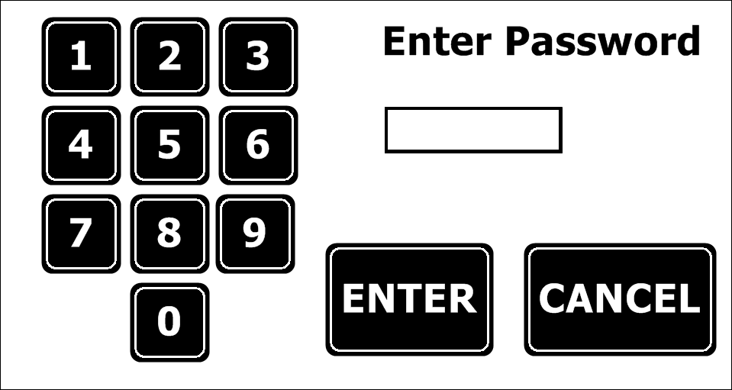

If you enter a wrong password, the screen will flash RED and clear the entry. You can try again.

The default 4 digit password is 1234. The 6 digit ‘technician’ password is 193728. The 4 digit password can be changed during setup and install, the 6 digit cannot.

### User Screen

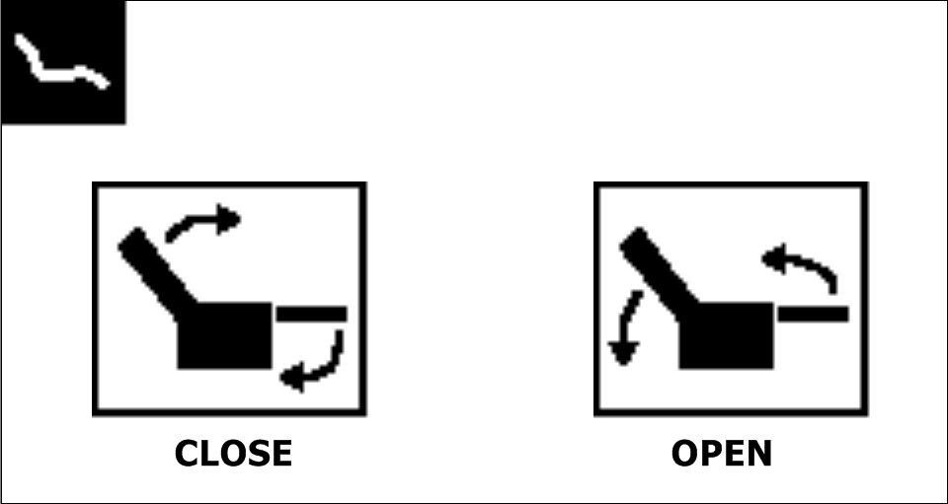

If you enter the 4 digit password correctly, this is the screen you will be brought to.

To operate the chairs, press and HOLD the CLOSE or OPEN button. When you release the button, the chair will stop moving in about 1 second. While pressing, the screen color will change to a light blue color to indicate the hub is sending the command. In order for these buttons to control the chairs, the chair must first be ‘synced’ with the hub. This is covered later in this guide. If the chair has not been ‘synced’ to the hub, the chair will ignore the command to OPEN or CLOSE.

Touching the chair icon in the upper right will revert back to the Welcome Screen, and the screen backlight will turn off in 5 seconds. If you do not touch any of the OPEN or CLOSE buttons for 1 minute, the hub will return to the welcome screen and turn off the screen backlight. To return to this screen, you must touch the Welcome screen and re-enter the 4 digit password.

### Technician Mode

If you enter the TECHNICIAN mode by entering the correct 6 digit password, this is the screen you will see.

This screen is the Technician 1 screen.

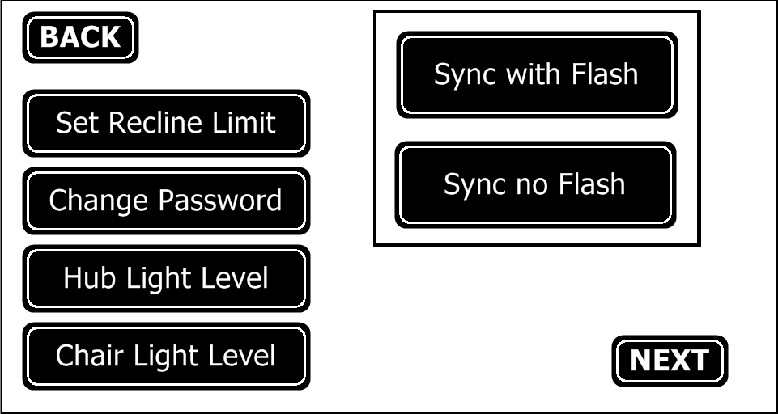

This is the function of each button:

**BACK** – returns you to the Welcome Screen

**Set Recline Limit** – takes you to the Set Recline Limit screen (shown below) and allows you to set the maximum recline limit of the chairs.

**Change Password** – allows you to change the 4 digit user password. See description below.

**Hub Light Level** – Takes you to the screen shown below and allows you to change the backlight of the HUB. 4 Levels are available, OFF, LOW, MED, and Maximum brightness. The default is MAX. See below

**Chair Light Level** – Takes you to the screen below and allows you to set the backlight level of the keypad for every chair. 7 Brightness levels are available, as well as OFF. Default is level 1 – the dimmest setting possible.

**Sync with Flash** and  **Sync no Flash** – Pairs the chairs with this hub so they only respond to commands from this hub.

See the description below.

Once either button is pressed, the screen will change to RED backlight, all other buttons will disappear, and the button will change to Stop Sending. To stop sending the Sync command, press the button and the screen will return to normal backlight, and the other buttons will re-appear.

**NEXT** – Moves you to the Technician 2 screen shown below.

#### Syncing chairs with the Hub

Most commands to the chair require the chair to be first ‘synced’ with the hub. This is to prevent a hub in one theater from affecting chairs in a neighboring theater.

There are 2 ways to SYNC a chair to the hub. The most common method will be to use the ‘Sync with Flash’ command. Pressing the button will turn the screen red to indicate the command is sending, and the screen will look like the one below with all buttons removed and only the ‘Stop Sending’ button shown.

This is the screen after pressing the Sync with Flash button:

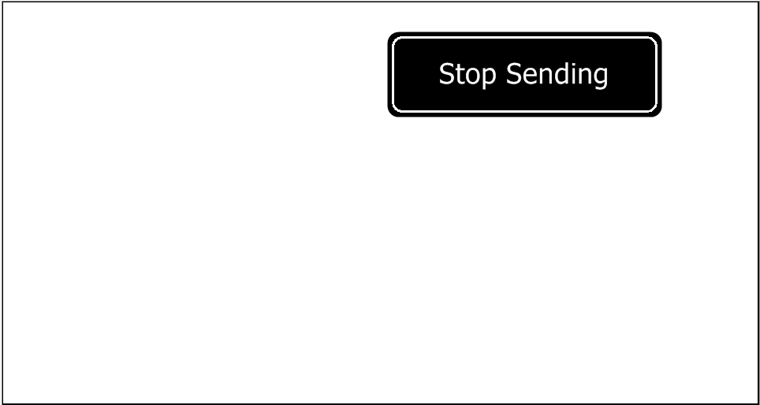

If you press the ‘Sync no Flash’ the screen will look the same. While the command is being sent, all chairs that are not already synced with this hub will flash once per second to indicate they are receiving the command and be synced to this hub. If the ‘Sync no Flash’ button is pressed, the chairs will not flash. This is done so chairs can be set up while another theater is in operation and it will not disturb the patrons.

If you simultaneously press the seat back ‘OPEN’ and ‘CLOSE’ buttons, the chair will flash 5 times to indicate it is now able to receive commands from the hub (synced), and the chair’s backlight will turn off. This is how you know a chair is synced with this hub – if the backlights go out when sending the command, it is synced to the hub. This happens with both the ‘Sync with Flash’ and ‘Sync no Flash’ command.

Once you click the ‘Stop Sending’ button, the hub display will return to a blue backlight and all the other buttons will become visible, and each chair’s keypad backlight will return to its programmed intensity after about 5 seconds.

If you click either Sync button, those chairs that are already synced to this hub will again turn off the keypad backlight to indicate they do not need to be synced to this hub.

If a chair receives a Sync command from another hub, it will flash its lights (or not if the Sync no Flash command is sent) and can be synced to the new hub as described above.

#### Set the Recline Limit

This is the screen after pressing the **Set Recline Limit** button:

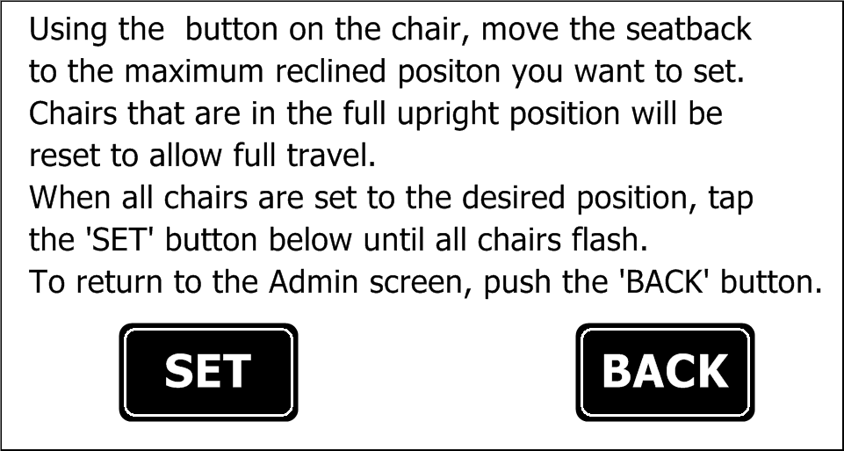

Using the switches on each chair, set each chair to the maximum recline position desired. If full travel is allowed, set the chair to the full upright position, you do not have to fully recline the chair. Once each chair is positioned, click the ‘SET’ button. Each chair that successfully receives the command will flash to indicate acknowledgement.

To reset a chair and allow full range or to allow it go back further, you should use the ‘OPEN’ command on the USER screen to recline all chairs to their maximum position, then using the chair’s controls, manually move the chair or chairs you want to allow more travel to the fully upright position. Then hit the SET button on the above screen to reset those chairs to full travel, and then without moving the other chairs, move the chairs you just reset to their new maximum position (if you want full travel, just leave the chair at the fully upright position), and again hit the SET button.

This is a 3 step process: 1) Recline all chairs to their maximum position, 2) reset the ones you want to allow more travel by bringing them fully upright, and click the SET button, and 3) move the chairs you want to change to their new position (if you want to allow full travel, just leave the chair in the full upright position) and hit the SET button again.

Note that if you want to reduce the travel of a chair, you do not have to reset it to allow full travel. In this case, move all chairs to the maximum recline position and then close the headrest of those you want less travel. Hit the SET button again to lock these changes in.

#### Change Password

Clicking the Change Password button brings you to this screen:

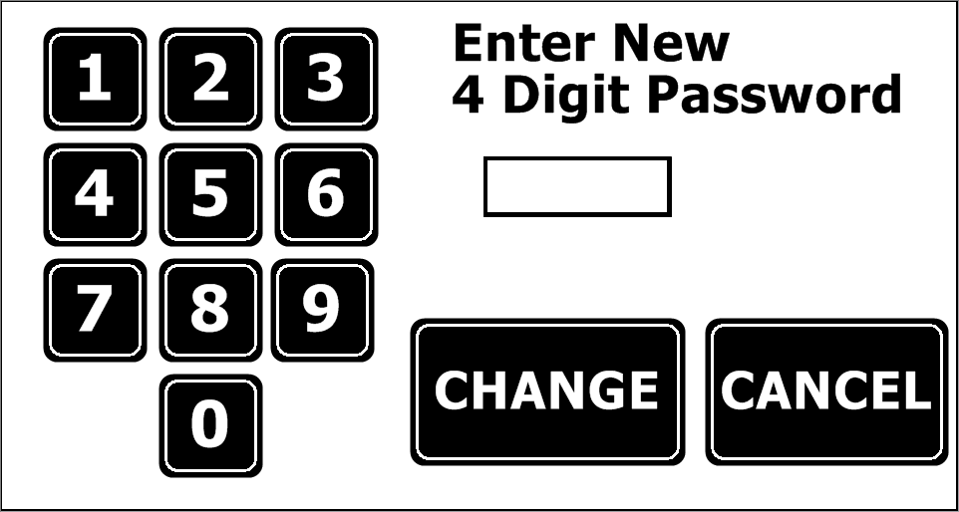

Enter a new 4 digit USER password and click CHANGE. If the password is accepted, the screen will flash GREEN. If you enter less than 4 digits, the screen will flash RED to indicate an error. If you enter more than 4 digits, the entry area will clear and the will start again with only the last number entered showing. Hitting CANCEL brings you back to the Technician screen. After a new 4 digit password is entered, and CHANGE is clicked, the CANCEL will change to DONE. Clicking on this DONE button will bring you back to the Technician Screen.

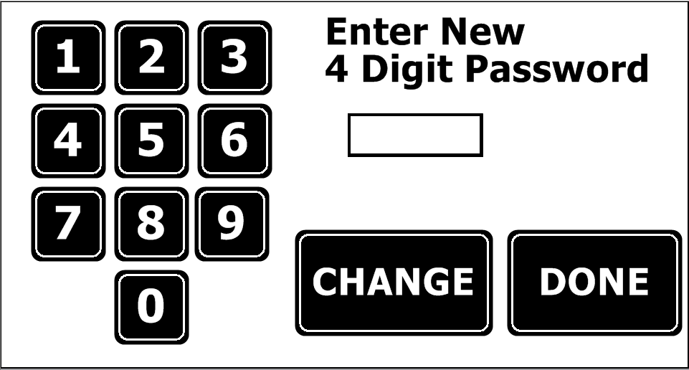

Screen with DONE button after entering a new 4 digit password and clicking CHANGE

#### 

#### Hub Light Level

Clicking the ‘Hub Light Level’ button allows you to change the backlight of the hub. There are four levels of brightness available, to accommodate various lighting conditions inside the theater. Pressing each of the buttons will immediately change the backlight level so the operator can set the desired light level. Clicking the back button returns you to the Technician screen.

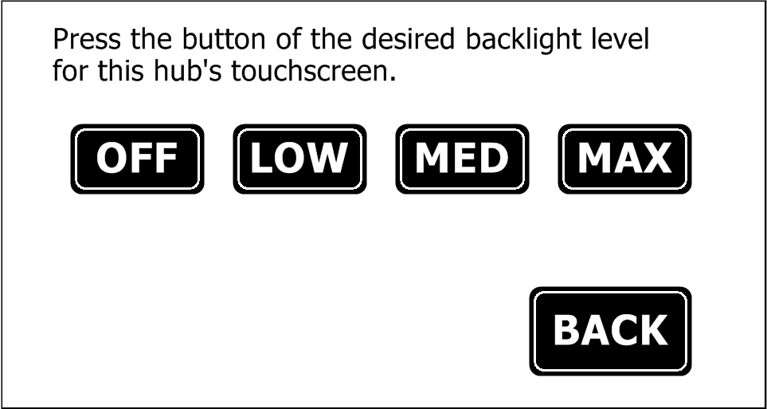

#### Chair Light Level

Clicking the chair light level button allows you to change the keypad backlight level for all of the chairs. There are eight levels of brightness available, with one of them being completely off. The default level is '1'. Selecting each level will immediately change all of the chairs backlight level so the operator can immediately see the results. Clicking the back button returns you to the main Technician screen.

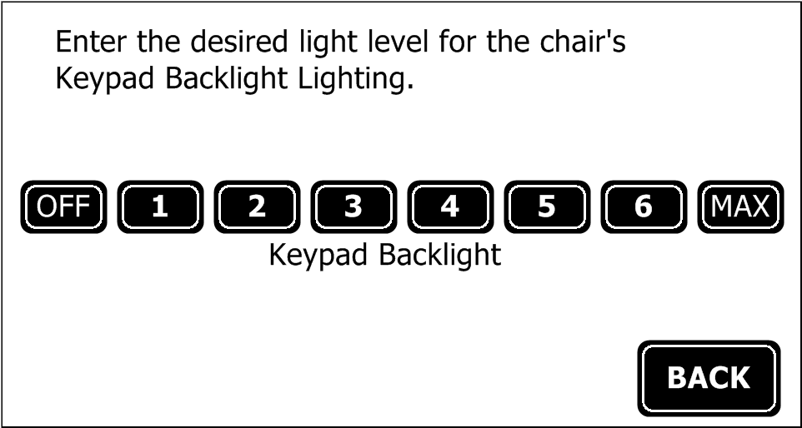

### Technician Mode – Screen 2

Clicking be NEXT button on the main technician screen will bring you to the screen below. Clicking back will return you to the main technician screen. Each of the buttons shown are described below.

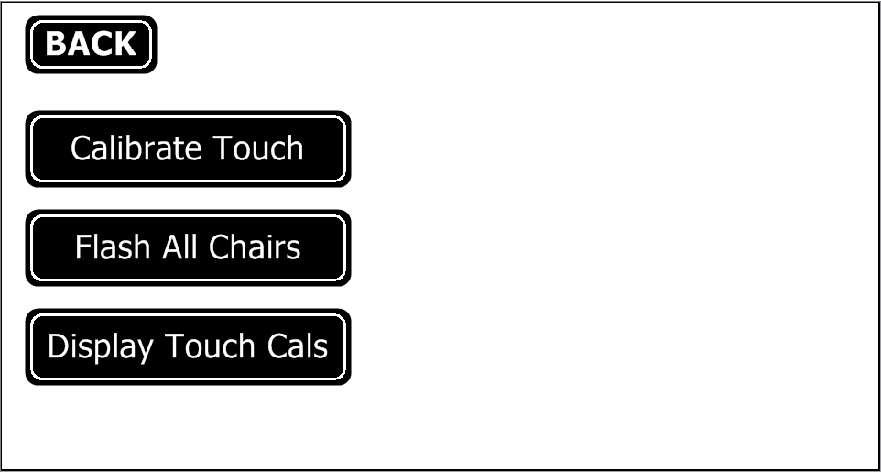

#### Calibrate Touch

Calibration of the touch panel is done during manufacturing, and it should not need to be adjusted during normal operation. If you are having problems with the buttons not responding or if a different button responds to a touch, it could be that the touch panel needs recalibration. Clicking the calibrate touch brings you to a calibration setup Wizard that will walk you through recalibrating the display. Care must be taken when calibrating the display, because incorrect calibration will result in missed registration of the buttons and will make operation very difficult.

After displaying the word ‘calibration’, a small dot will appear in the lower left corner of the screen. Using a pointed object, such as the tip of a small Phillips screwdriver or a paperclip, click on the dot in the corner being as precise as you can. Once this is clicked a similar dot will appear in the upper right corner, and again being as precise as possible click on that. If the calibration was successful in the positions were within limits. The numbers will be momentarily displayed on the screen, and then the screen will return to the Technician 2 screen. If the numbers are out of range the screen will flash red and require you to touch the two dots in the lower and upper corners again, until you are successful.

#### Flash All Chairs

This command allows technicians to test that every chair is capable of receiving command sent from the hub. This command does NOT require syncing a chair to the hub, all chairs within radio range of the hub will respond to this command. Pressing the Flash All Chairs button, will begin continuously sending the command, the screen will turn red to indicate the command is being sent, and only a Stop Sending button will be displayed. Pressing the Stop Sending button will revert the screen back to blue, and all buttons will again be visible. Chairs receiving this command will flash once per second to indicate they are receiving the transmission from this hub. This can be used during setup to ensure all chairs are within radio range of the hub, or to position a hub optimally within the theater.

This command should not be used while other theaters are in use, as any chair within radio range of the Hubble will respond to the command whether it is synced or not.

#### Display Touch Cals

Clicking this button brings up the calibration constants for the touch panel, as well as the serial number of the hub. These numbers and the serial number of the hub are used during troubleshooting and in manufacturing.

Final notes:

All commands to the chairs including OPEN, CLOSE, Set Recline Limit etc. require the chair to be synced to the hub. There are two commands which do NOT require a chair to be synced with a hub in order for the chair to respond. These include the 'Sync' commands, and the Flash All Chairs’ command.

Flow diagram of the Hub Menus

